Switch operates the power to the LCD, Reed switch and ES308 Rabbit SBC. The box has eight D-cell batteries in a battery pack that provides +12 volts to the Rabbit and +6 volts to the display and reed switch.

LCD Display
4 lines by 20 characters.

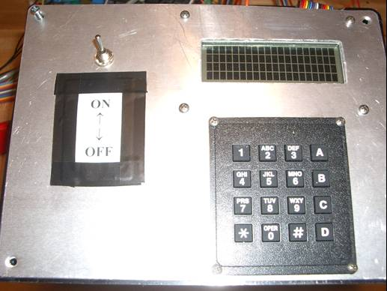
Keypad, only the bottom line is used by the Virtual Coxswain Dynamic C program.
Enclosure 18

